**MACHINE LEARNING ASSIGNMENT 4**

**STUDENT ID: 700766162**

**NAME: SRAVANI MANNURU**

**Github link**: https://github.com/sravs2031/Machine-Learning-Assignment-4.git

**Video link**: https://drive.google.com/file/d/1y557Hgo0EB3yCWkdykb1N-teAx_ulyuQ/view?usp=drive_link

**Screenshots:**

**1)**

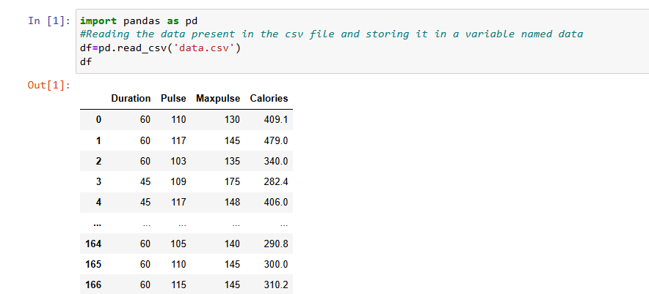

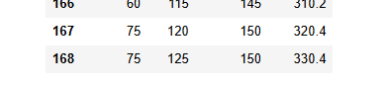

**2)**

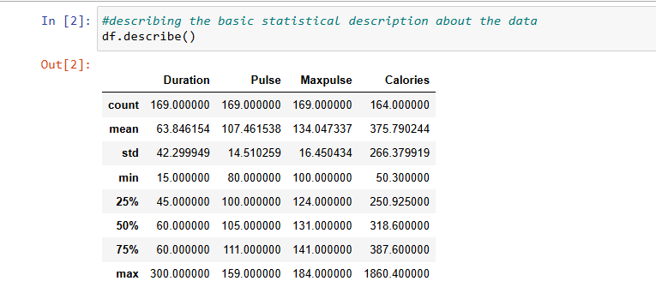

**3)**

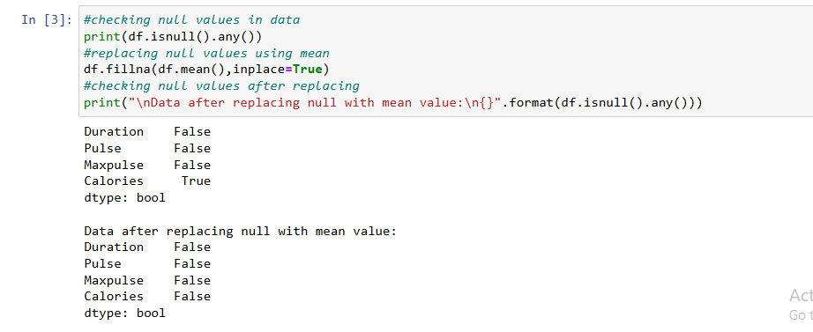

**4)**

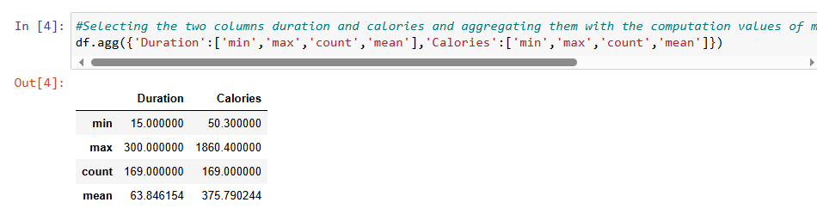

**5)**

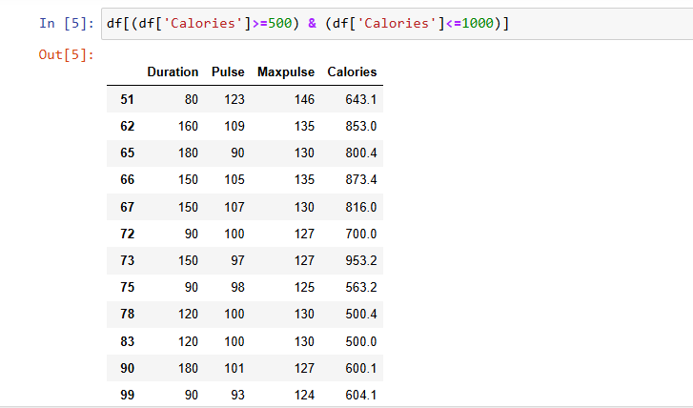

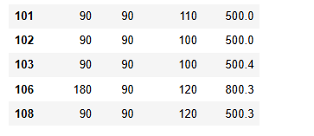

**6)**

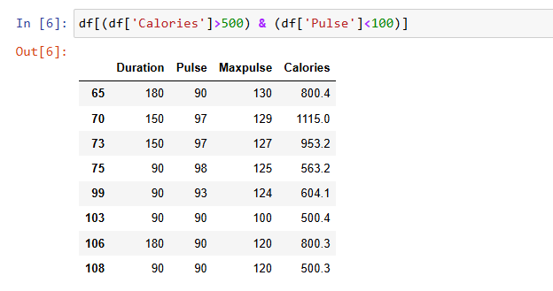

**7)**

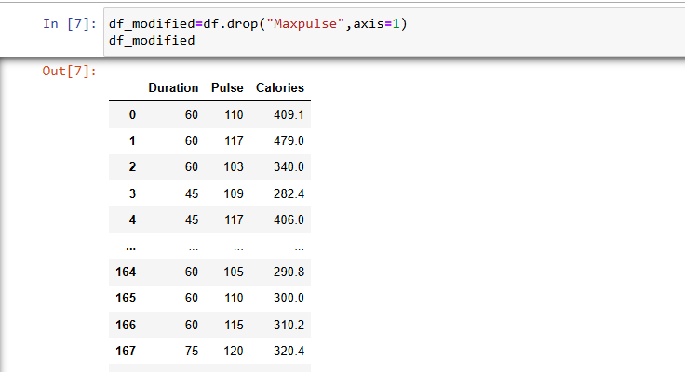

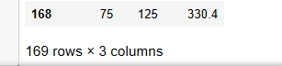

**8)**

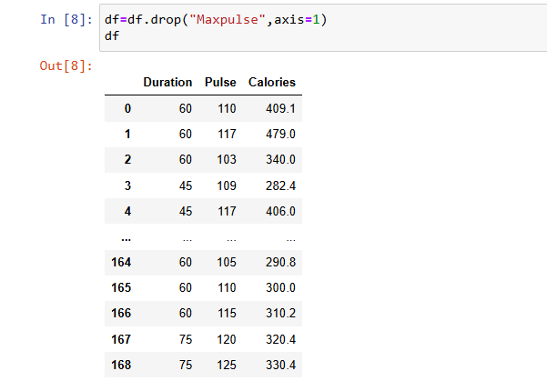

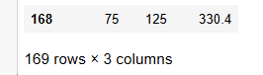

**9)**

